**Name: Abinash Satapathy**

**Reg. No.: 16BCE0081**

**Slot: L27 + L28**

**Subject: Networking (CSE1004) lab**

**Experiment 5**

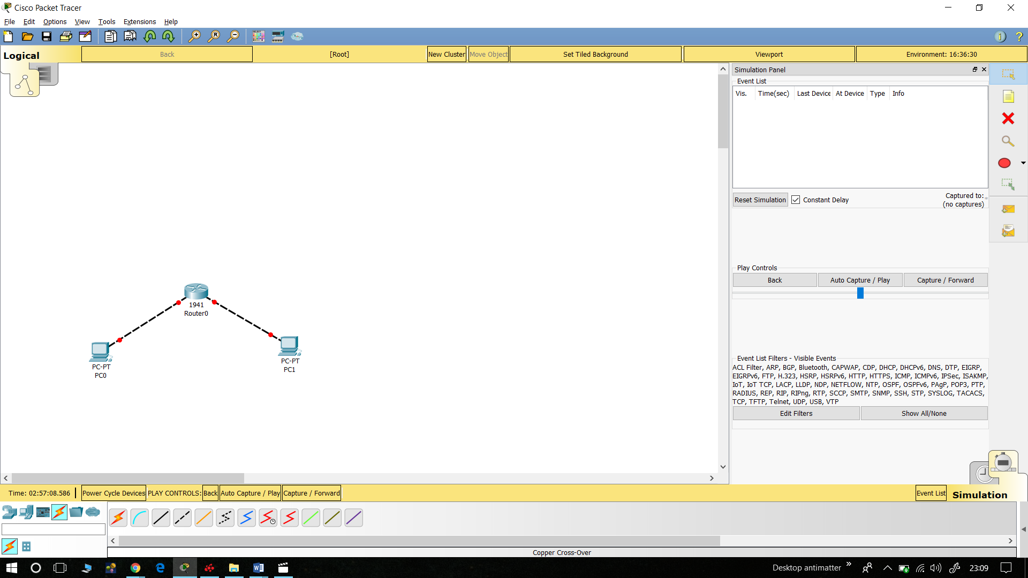

System Bootstrap, Version 12.3(8r)T8, RELEASE SOFTWARE (fc1)

Cisco 1841 (revision 5.0) with 114688K/16384K bytes of memory.

Readonly ROMMON initialized

Self decompressing the image :

########################################################################## [OK]

Restricted Rights Legend

Use, duplication, or disclosure by the Government is

subject to restrictions as set forth in subparagraph

(c) of the Commercial Computer Software - Restricted

Rights clause at FAR sec. 52.227-19 and subparagraph

(c) (1) (ii) of the Rights in Technical Data and Computer

Software clause at DFARS sec. 252.227-7013.

cisco Systems, Inc.

170 West Tasman Drive

San Jose, California 95134-1706

Cisco IOS Software, 1841 Software (C1841-ADVIPSERVICESK9-M), Version 12.4(15)T1, RELEASE SOFTWARE (fc2)

Technical Support: http://www.cisco.com/techsupport

Copyright (c) 1986-2007 by Cisco Systems, Inc.

Compiled Wed 18-Jul-07 04:52 by pt_team

Image text-base: 0x60080608, data-base: 0x6270CD50

This product contains cryptographic features and is subject to United

States and local country laws governing import, export, transfer and

use. Delivery of Cisco cryptographic products does not imply

third-party authority to import, export, distribute or use encryption.

Importers, exporters, distributors and users are responsible for

compliance with U.S. and local country laws. By using this product you

agree to comply with applicable laws and regulations. If you are unable

to comply with U.S. and local laws, return this product immediately.

A summary of U.S. laws governing Cisco cryptographic products may be found at:

http://www.cisco.com/wwl/export/crypto/tool/stqrg.html

If you require further assistance please contact us by sending email to

export@cisco.com.

Cisco 1841 (revision 5.0) with 114688K/16384K bytes of memory.

Processor board ID FTX0947Z18E

M860 processor: part number 0, mask 49

2 FastEthernet/IEEE 802.3 interface(s)

191K bytes of NVRAM.

63488K bytes of ATA CompactFlash (Read/Write)

Cisco IOS Software, 1841 Software (C1841-ADVIPSERVICESK9-M), Version 12.4(15)T1, RELEASE SOFTWARE (fc2)

Technical Support: http://www.cisco.com/techsupport

Copyright (c) 1986-2007 by Cisco Systems, Inc.

Compiled Wed 18-Jul-07 04:52 by pt_team

--- System Configuration Dialog ---

Continue with configuration dialog? [yes/no]: n

Press RETURN to get started!

Router>config

Translating "config"...domain server (255.255.255.255)

% Unknown command or computer name, or unable to find computer address

Router>config t

^

% Invalid input detected at '^' marker.

Router>config t

^

% Invalid input detected at '^' marker.

Router>enable

Router#config t

Enter configuration commands, one per line. End with CNTL/Z.

Router(config)#line vty 0 4

Router(config-line)#password cisco

Router(config-line)#login

Router(config-line)#exit

Router(config)#interface FastEthernet0/0

Router(config-if)#ip address 10.10.1.1 255.255.255.0

Router(config-if)#description Router0 FastEthernet0/0

Router(config-if)#no shutdown

Router(config-if)#

%LINK-5-CHANGED: Interface FastEthernet0/0, changed state to up

%LINEPROTO-5-UPDOWN: Line protocol on Interface FastEthernet0/0, changed state to up

Router(config-if)#exit

Router(config)#show running-config

^

% Invalid input detected at '^' marker.

Router(config)#exit

Router#

%SYS-5-CONFIG_I: Configured from console by console

Router#show running-config

Building configuration...

Current configuration : 615 bytes

!

version 12.4

no service timestamps log datetime msec

no service timestamps debug datetime msec

no service password-encryption

!

hostname Router

!

!

!

!

!

!

!

!

ip cef

no ipv6 cef

!

!

!

!

!

!

!

!

!

!

!

!

spanning-tree mode pvst

!

!

!

!

!

!

interface FastEthernet0/0

description Router0 FastEthernet0/0

ip address 10.10.1.1 255.255.255.0

duplex auto

speed auto

!

interface FastEthernet0/1

no ip address

duplex auto

speed auto

shutdown

!

interface Vlan1

no ip address

shutdown

!

ip classless

!

ip flow-export version 9

!

!

!

!

!

!

!

line con 0

!

line aux 0

!

line vty 0 4

password cisco

login

!

!

!

end

Router#

TCP

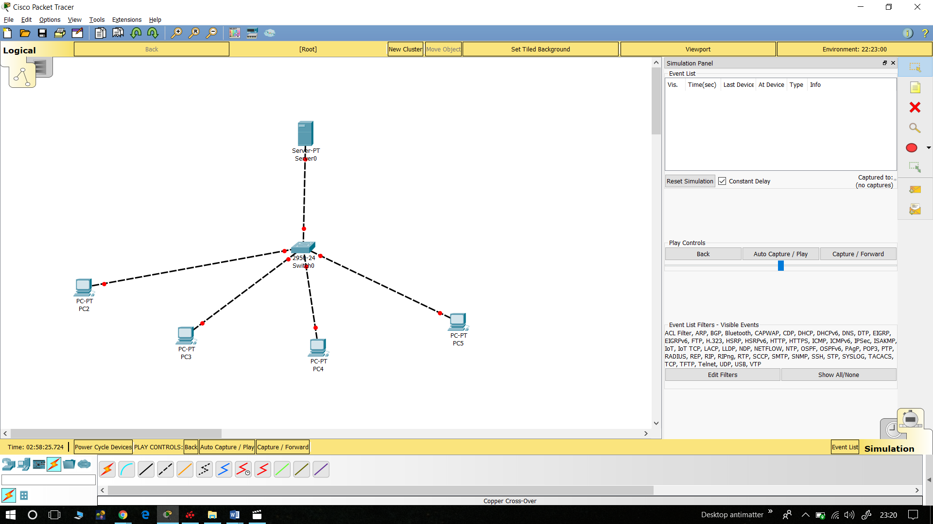

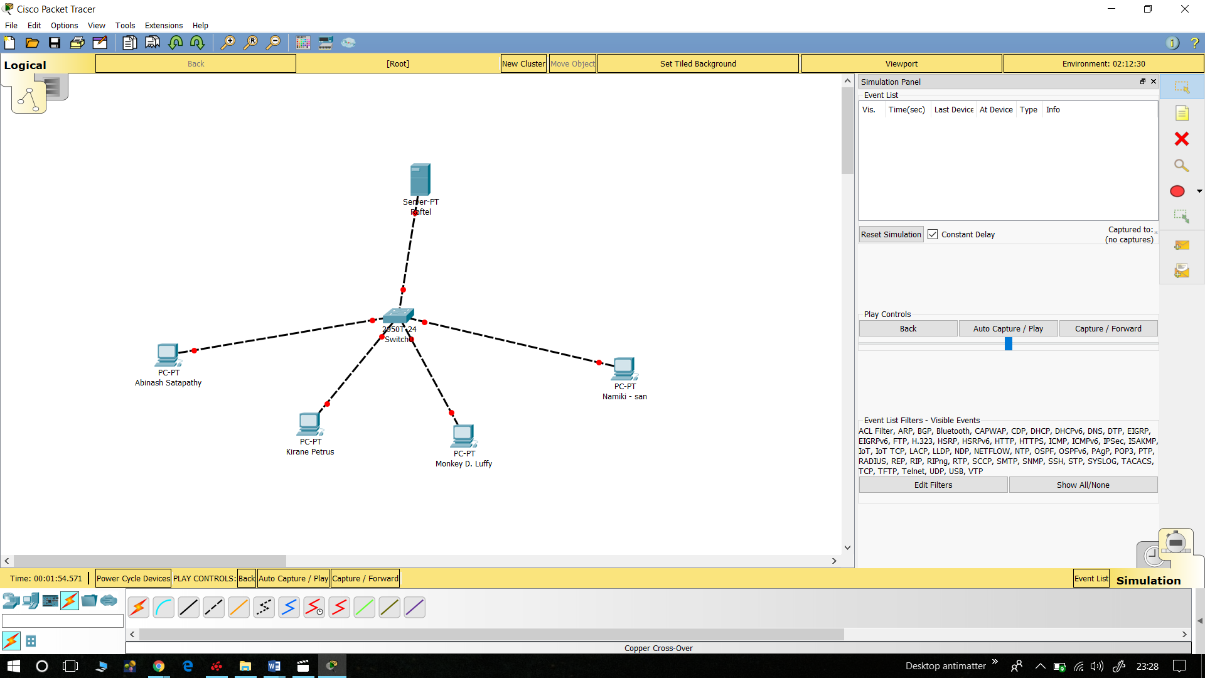

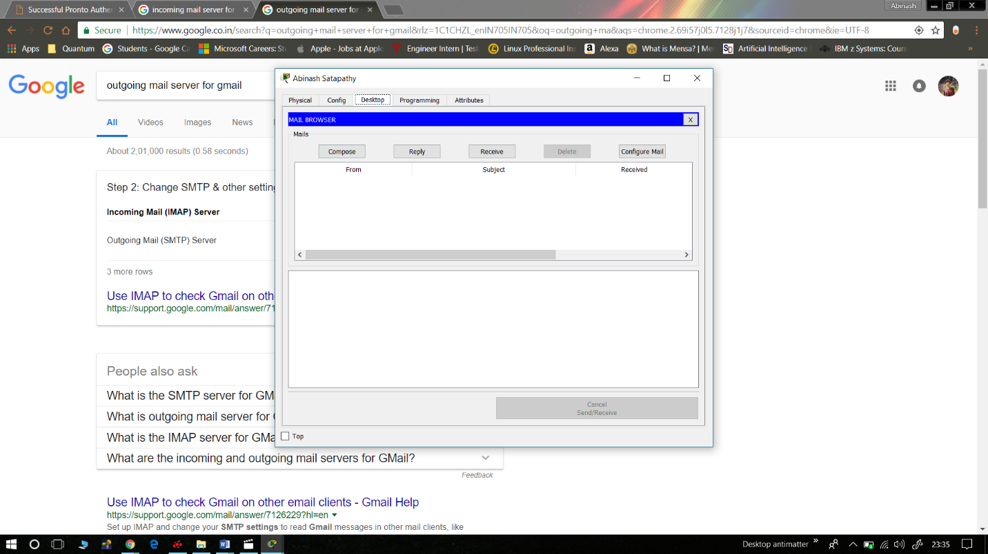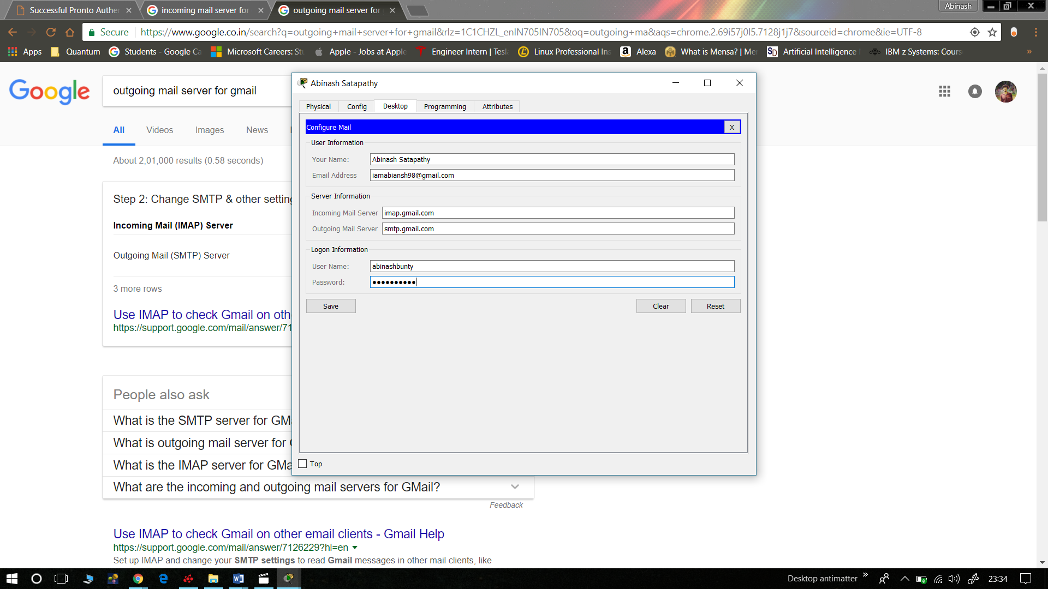

C2950 Boot Loader (C2950-HBOOT-M) Version 12.1(11r)EA1, RELEASE SOFTWARE (fc1)

Compiled Mon 22-Jul-02 18:57 by miwang

Cisco WS-C2950T-24 (RC32300) processor (revision C0) with 21039K bytes of memory.

2950T-24 starting...

Base ethernet MAC Address: 0090.2B32.E4B3

Xmodem file system is available.

Initializing Flash...

flashfs[0]: 1 files, 0 directories

flashfs[0]: 0 orphaned files, 0 orphaned directories

flashfs[0]: Total bytes: 64016384

flashfs[0]: Bytes used: 3058048

flashfs[0]: Bytes available: 60958336

flashfs[0]: flashfs fsck took 1 seconds.

...done Initializing Flash.

Boot Sector Filesystem (bs:) installed, fsid: 3

Parameter Block Filesystem (pb:) installed, fsid: 4

Loading "flash:/c2950-i6q4l2-mz.121-22.EA4.bin"...

########################################################################## [OK]

Restricted Rights Legend

Use, duplication, or disclosure by the Government is

subject to restrictions as set forth in subparagraph

(c) of the Commercial Computer Software - Restricted

Rights clause at FAR sec. 52.227-19 and subparagraph

(c) (1) (ii) of the Rights in Technical Data and Computer

Software clause at DFARS sec. 252.227-7013.

cisco Systems, Inc.

170 West Tasman Drive

San Jose, California 95134-1706

Cisco Internetwork Operating System Software

IOS (tm) C2950 Software (C2950-I6Q4L2-M), Version 12.1(22)EA4, RELEASE SOFTWARE(fc1)

Copyright (c) 1986-2005 by cisco Systems, Inc.

Compiled Wed 18-May-05 22:31 by jharirba

Cisco WS-C2950T-24 (RC32300) processor (revision C0) with 21039K bytes of memory.

Processor board ID FHK0610Z0WC

Running Standard Image

24 FastEthernet/IEEE 802.3 interface(s)

2 Gigabit Ethernet/IEEE 802.3 interface(s)

63488K bytes of flash-simulated non-volatile configuration memory.

Base ethernet MAC Address: 0090.2B32.E4B3

Motherboard assembly number: 73-5781-09

Power supply part number: 34-0965-01

Motherboard serial number: FOC061004SZ

Power supply serial number: DAB0609127D

Model revision number: C0

Motherboard revision number: A0

Model number: WS-C2950T-24

System serial number: FHK0610Z0WC

Cisco Internetwork Operating System Software

IOS (tm) C2950 Software (C2950-I6Q4L2-M), Version 12.1(22)EA4, RELEASE SOFTWARE(fc1)

Copyright (c) 1986-2005 by cisco Systems, Inc.

Compiled Wed 18-May-05 22:31 by jharirba

Press RETURN to get started!

Switch>